Bitcoin Investment

# **Introduction**

The implementation of Bitcoin as open-source software twelve years ago has turned out to be a pivotal moment for the financial markets. Bitcoin was conceived in a whitepaper published on 31 October 2008 as a decentralised digital currency. It is decentralised in the sense that as a cryptographic currency - dubbed 'cryptocurrency' - it is neither issued nor managed by a single administrative authority such as a central bank. Instead, Bitcoin relies on a peer-to-peer bitcoin network, and is created as an incentive for node operators to engage in a process called mining. Transactions, through which the currency is sent or received, are conducted on the bitcoin network. The transactions are cryptographically verified by nodes on the network and recorded in an immutable, publicly distributed ledger called a blockchain.

The most prominent criticism when it comes to investing in Bitcoin is that of price volatility. The bitcoin price has gone through dramatic cycles of appreciation and depreciation. Indeed, this has become a defining feature of cryptoassets in general, with other popular cryptoassets such as Ethereum (the second largest cryptoasset by market capitalisation) exhibiting similar tendencies. The cryptoasset class is historically known to be several times more volatile than other traditional asset classes such as gold and equity indices. However, is this reason enough for an investment fund to completely avoid investing in Bitcoin? After all, high volatility can also present an opportunity for higher returns. This report seeks to provide answers to this question, based on recent market data. The aim of the report is to assess the suitability of investing some of a fund's assets into Bitcoin. This will be accomplished by analysing Bitcoin purely from an investment perspective, and comparing the asset to two traditional assets, namely gold and the S&P 500 index.

The research conducted in the report is guided by the following questions:

* **How does the performance of Bitcoin compare to the S&P 500 ?**
* **Could adding Bitcoin improve the performance of a portfolio?**
* **Can Bitcoin be used as a hedge against inflation?**
* **Can we build a portfolio using some or all of these assets?**

The investment fund's CFO is seeking to lower volatility in the fund. Therefore, the recommendations from this report prioritise the minimisation of overall risk.

# **Import librairies**

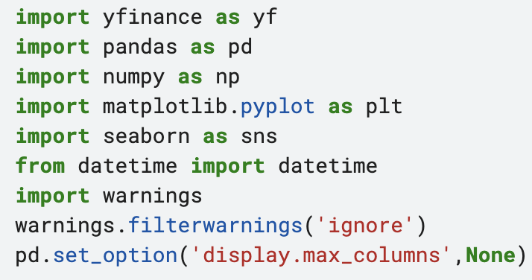

# **Data**

We use yfinance API to scrape data from Yahoo Finance website.

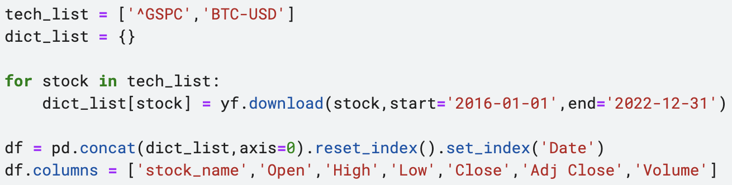

Data:

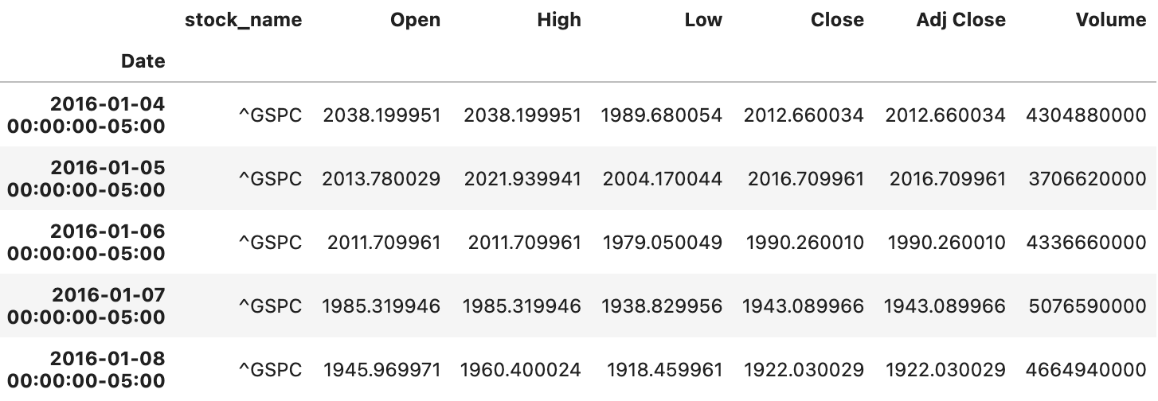

Save data into two dataframe: bitcoin and sp500

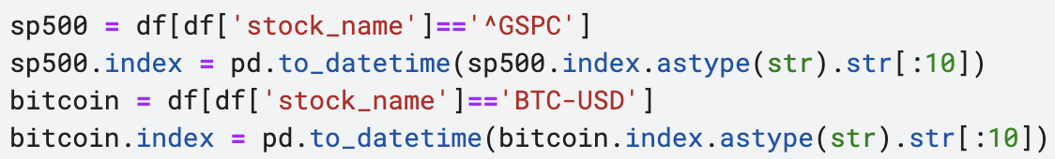

Import data about CPI and create a new column ‘year_month’ for analysis after:

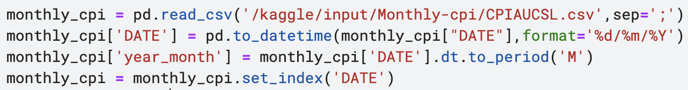

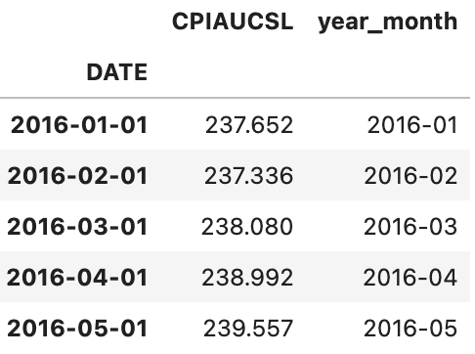

# **Bitcoin and S&P500 Analysis**

**1. Price**

We can see through this visualization that the price of Bitcoin and S&P500 were quite stable until mid 2017 when Bitcoin became popular and easier to trade with. It has a significant increase since 2018. We can see after that increase that Bitcoin was not as stable as before. Investment on Bitcoin in the mid 2017 may be a good choice in a long term. There are two highest peak in early 2021 and early 2022 and since 2022 the price of Bitcoin began to decline.

About S&P500 price, we can see that stability compare to Bitcoin. It is more predictable than Bitcoin. Investors are able to follow their investments and predict the market. We assume that the votality of Bitcoin is more than S&P500.

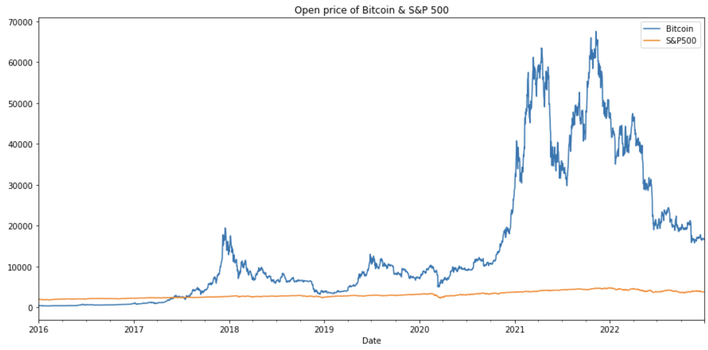

**2. Volume**

Volume is the amount of an asset or security that changes hands over some periods of time. Stock trading volume refers to the number of shares of a security traded between its daily open price and close.

We can see in the Bitcoin visualization there isn't much activities until late 2017, as remember that Bitcoin unstability in mid 2017 due to its popularity then the volume started increasing. There is a relationship between the volume and the price of Bitcoin. When the volume increases, then the price increases also.

On the other hand, the volume of S&P500 has a fluctuation. There are two highest peak in early 2020 and early 2021. If we see the diagram above, the price of S&P500 in early 2020 fall down and people saw a chance to buy stocks.

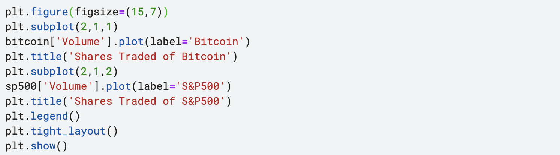

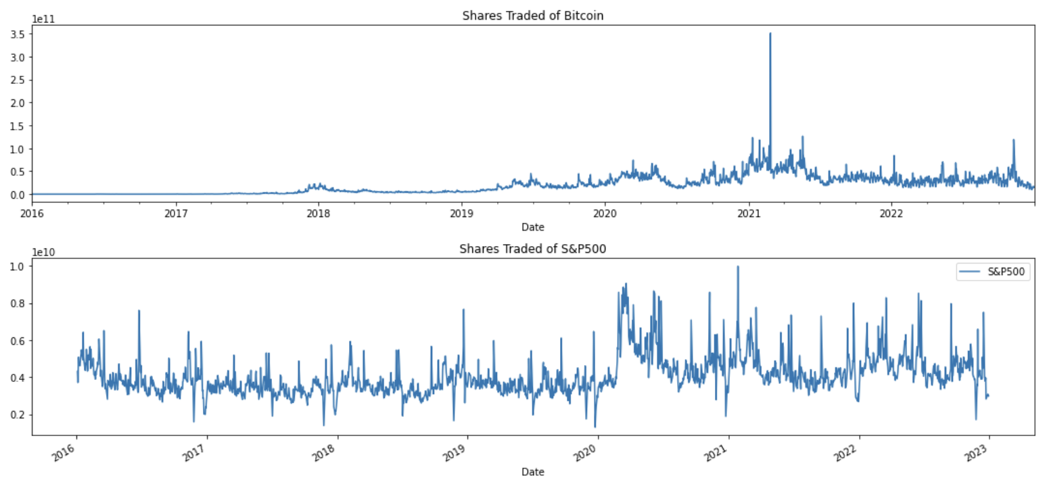

**3. Bitcoin Investment in action**

The diagrams below show you Bitcoin investment in action. Look at the price of Bitcoin in January, this is the first highest peak more then 45000 dollars. Then the price fall down to 35000 dollars late January. We can see the instability in the price of Bitcoin after January which drove a lot of people away because they could not predict the movement of Bitcoin and saw high risk involved.

In early April, there is the highest peak. Then later it fall down to 40000 dollars.  
In early May, the price fall from 40000 dollars to 30000 dollars. And during the same period, the volume of Bitcoin spike which means a lot of people traded in Bitcoin.

Another exemple is in mid June, there is the second lowest peak, we can see that the price of Bitcoin fall down below 20000. And the third lowest peak is in early November.

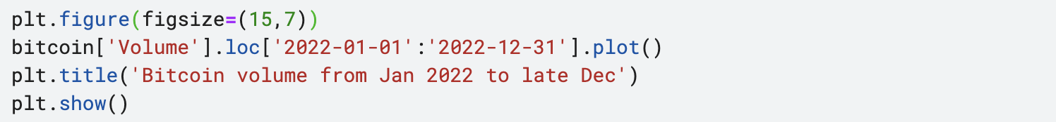

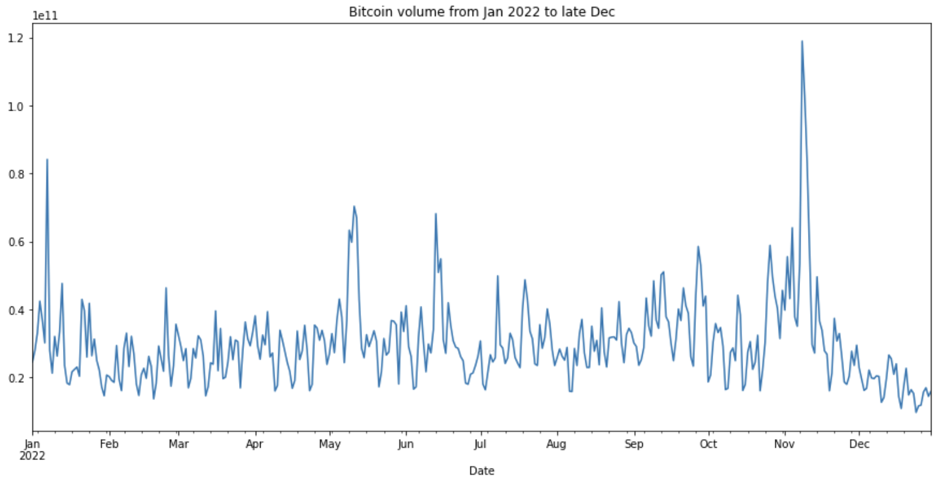

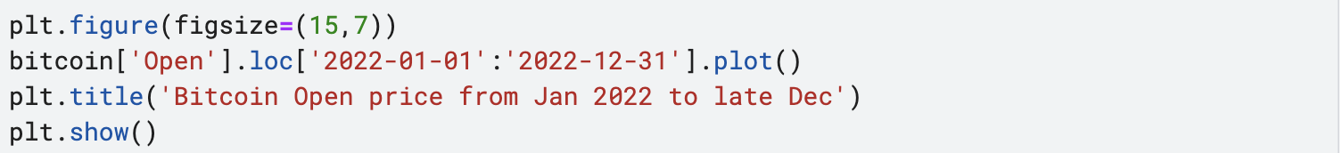

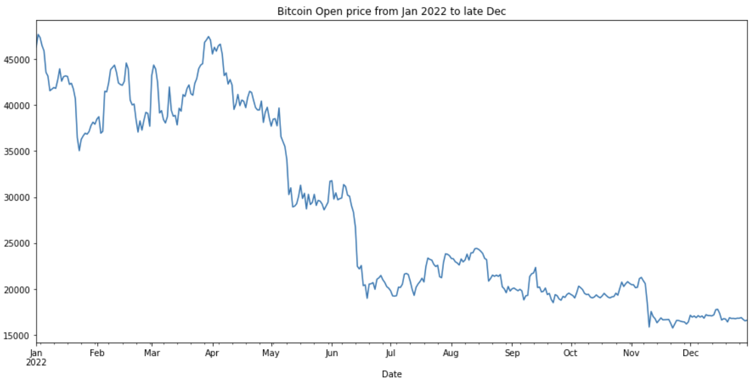

**4. Moving Average**

In statistics, a moving average is a calculation used to analyze data points by creating a series of averages of different subsets of the full data set. In finance, a moving average (MA) is a stock indicator that is commonly used in technical analysis. The reason for calculating the moving average of a stock is to help smooth out the price data by creating a constantly updated average price.

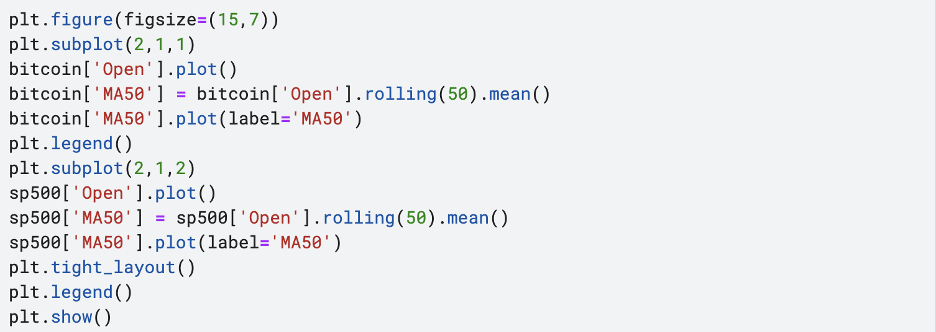

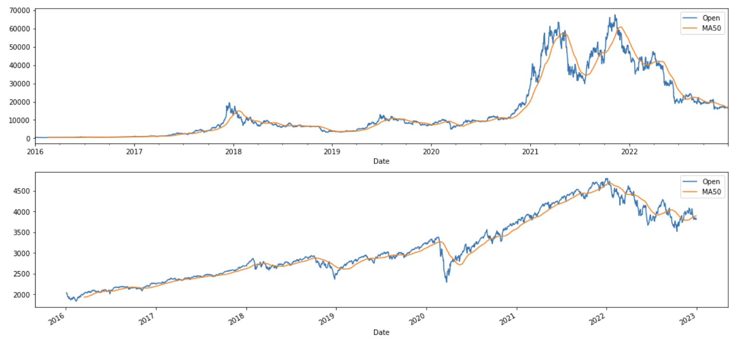

**5. Candlestick**

This is the candlestick graph to understand it better it shows the opening price, closing price , higest price,lowest price for each day.

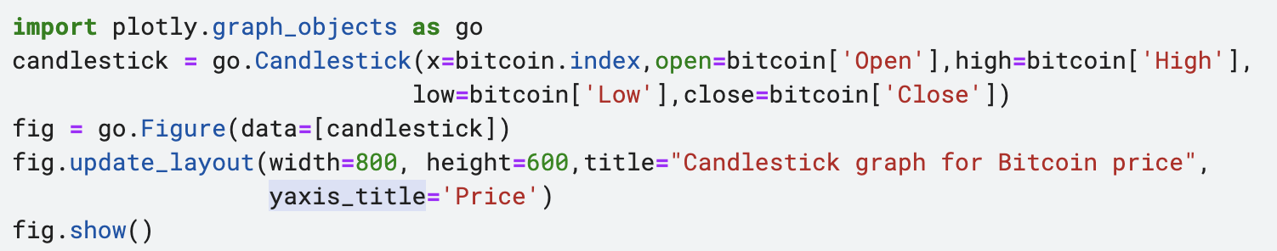

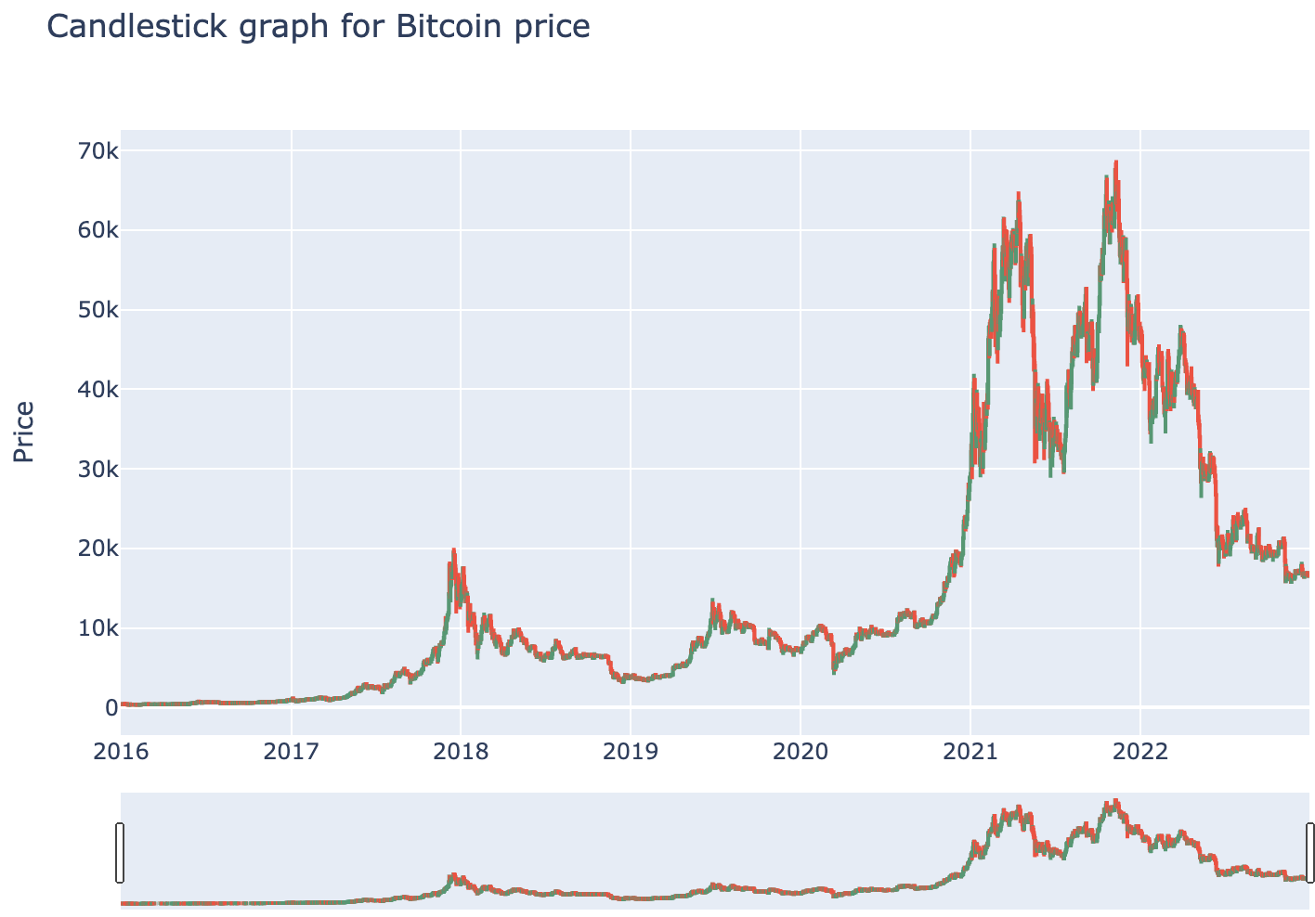

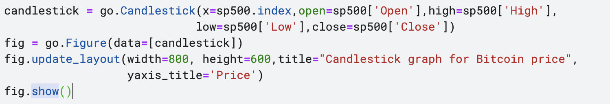

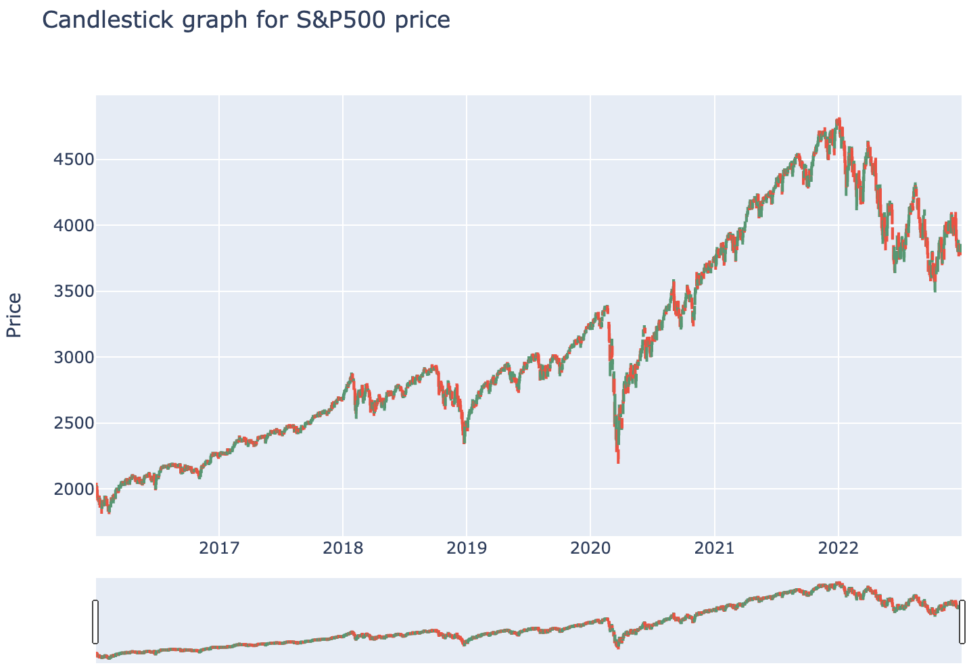

**6. Daily percentage change**

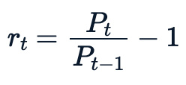

The easiest way to explian this formular

- the return at a given period  - the closing price at a given day

 -the closing price a day before

The value reports that a percentage gain or loss. Assume we but a stock at  and sold it at . If  is greater than  there would be a profit. On the other hand, if you sold  is less than  there would be a loss. While this isn't necessarily helpful in analyzing the volatility of a stock. What we are trying to achieve is found when we plot the daily percentage change or returns in a histogram or Kernel density estimation(kde). If the daily returns have a wide distribution the stock is volatile.



**6.1 Histogram visualization for Volatility**

In this histogram, the wider histogram the more volatile the stock. The width of the bell shape is related to the standard deviation. The higher the standard deviation the more the variance and more volatile.

As we can see the diagram of Bitcoin is more volatile then S&P500.

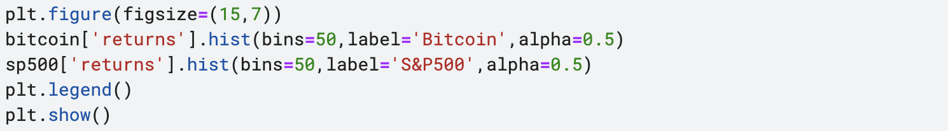

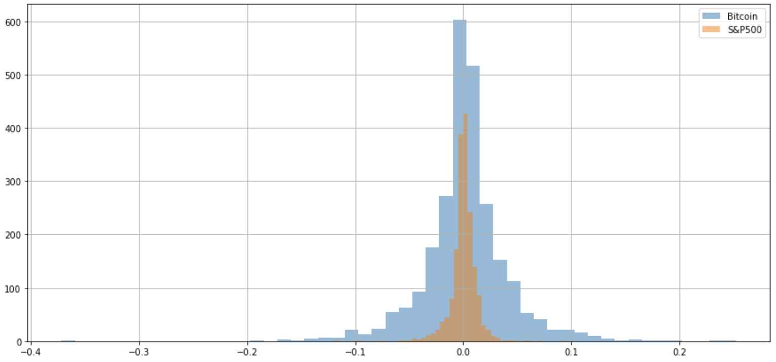

**6.2 KDE visualization for Volatility**

Another visualization is the Kernel density estimation(kde) reports a cetain probability distribution function as for histogram is unnormalized and kde is normalized, so that the area of each density is constant. We can't only judge from histogram alone. We have to normalized.

Visually the Bitcoin KDE is wider which means is more volatile.

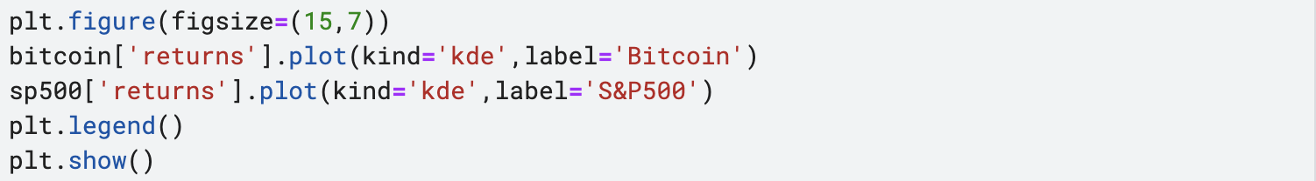

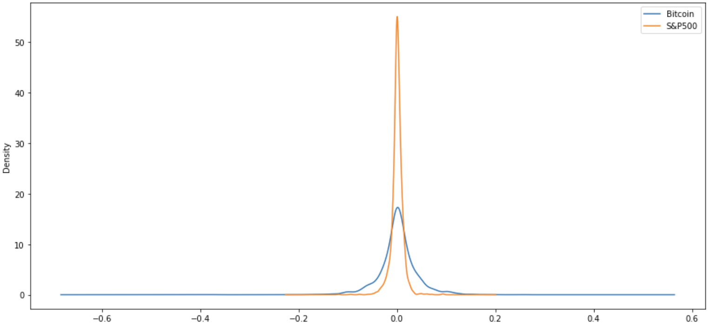

**6.3 Boxplot visualisation for Volatility**

Boxplot is informative also. As we can see in this boxplot about daily percentage change for Bitcoin returns is way spead out than S&P500 returns which means that Bitcoin is more volatile then S&P500 over the years.

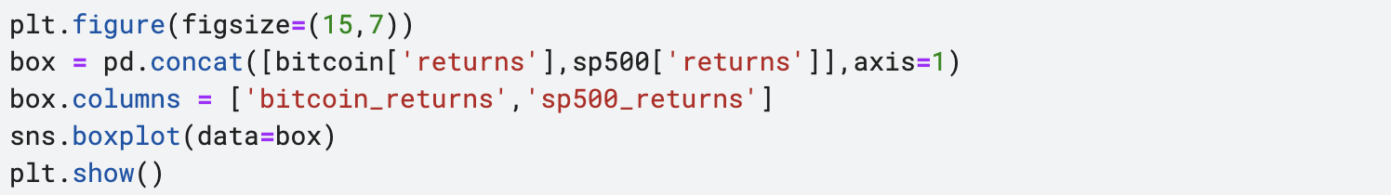

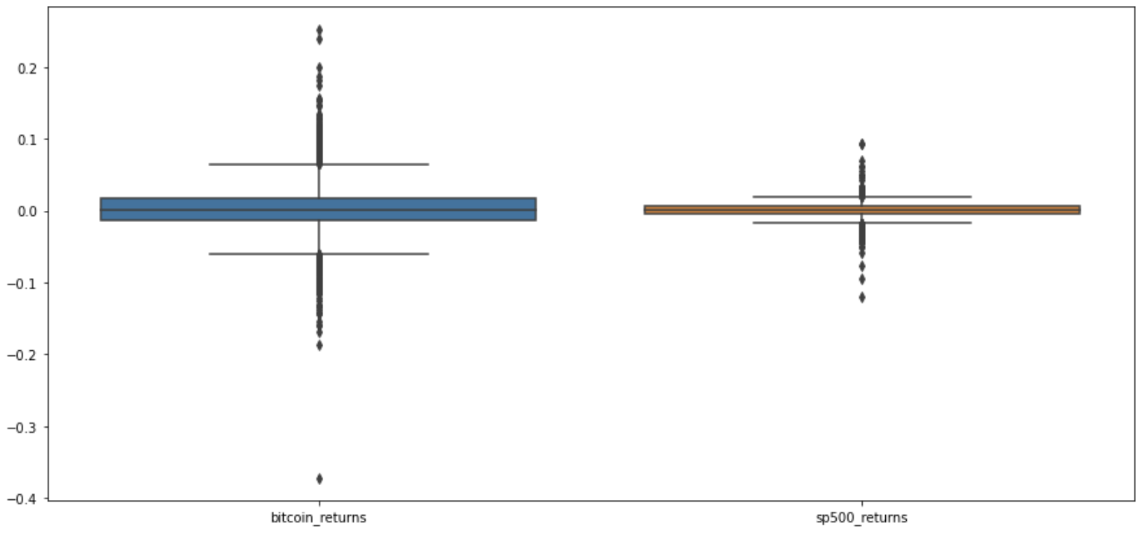

**7. Portfolio performance**

One main concern of investment is to know how well our investment portfolio performs in a market full of fluctuation and uncertainty. We need some key performance indicators to measure the returns as well as the risk of our investment portfolio. Measurement of returns and risk are always coupled togather to give a more balanced evaluation of our investment plan.

### **7.1 Compound Annual Growth Rate(CAGR)**

The Compound Annual Growth Rate(CAGR) is the rate of return that would be requied for an investment to grow from the beginning to the ending balance, assuming the profits were reinvested at the end of each period of the investment's life span.

* Investors can compare the CAGRof two alternatives to evaluate how well one stock performed against other stocks in a peer group or a market index.
* The CAGR does not reflect the investment risk

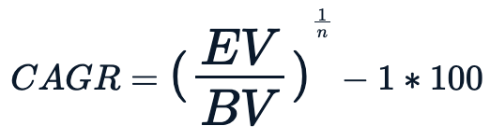

where;

EV- Ending value

BV- Beginning value

n- Number of years

**Example of How to Use CAGR**

Imagine you invested $10 in a portfolio with the returns outlined below:

* From Jan. 1, 2019, to Jan. 1, 2020, your portfolio grew to $13 (or 30% in year one).
* On Jan. 1, 2021, the portfolio was $14 (or 7.69% from January 2020 to January 2021).
* On Jan. 1, 2021, the portfolio ended with $19 (or 35.71% from January 2021 to January 2022).

On the other hand, the compound annual growth rate smooths the investment’s performance and ignores the fact that 2018 and 2020 were vastly different from 2019. The CAGR over that period was 23.86% and can be calculated as follows:

therefore the compound annual growth rate for bitcoin is 43.22% This is relatively high for amount of years. therefore the compound annual growth rate for sp 500 is 9.68%.

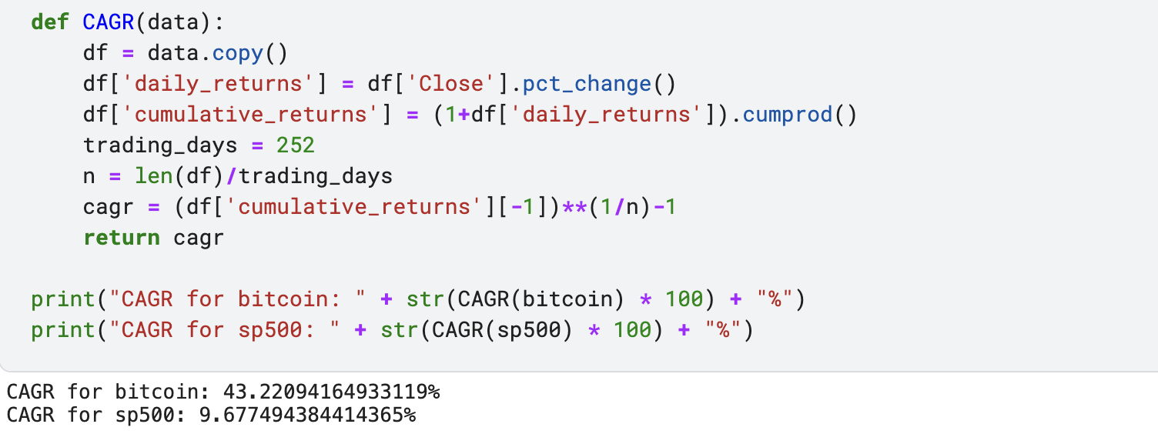

**7.2 Annualized Volatility**

Volatility here refers to the rate at which the stock price instability over a particular period of time. It is equivalent to the standard deviation of the daily returns. The higher the stock volatility the higher the risk of the investment. The volatility is usually expressed in annual terms. The formula of annualized volatility is just the multiplication of standard deviation of daily returns with the square root of trading days per year.



**where;**

SD-daily - stardard deviation of daily returns

t- Number of trading days per years

The calculated volatility is more than 50% in Bitcoin thats means the bitcoin is really instable compare to S&P500.

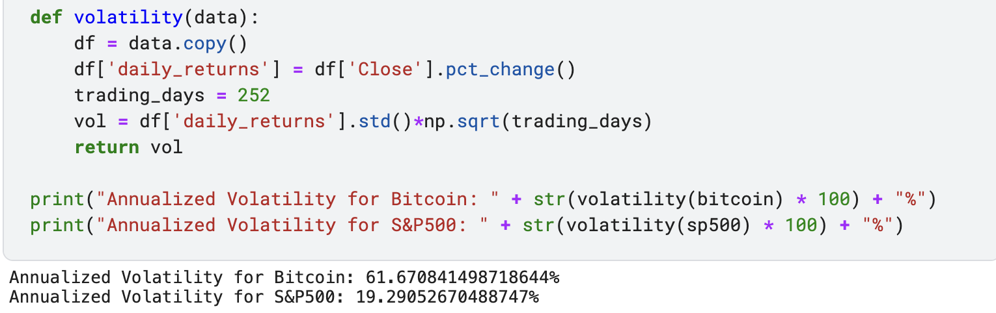

**7.3 Sharpe Ratio**

Sharpe Ratio is the average return earned in excess of the risk-free rate per unit of volatility. In simpler words, the ratio allows investors to understand the return of an investment compared to its risk. Any ratio higher than 1 is considered a good portfolio. The higher the ratio the better the investment portfolio. While CAGR and annualized volatility only take care of either returns or volatility, respectively, Sharpe Ratio takes both into consideration. The risk-free rate of returns refers to the returns on investment with zero risks such as the U.S. Treasury Bond. The formula of the Sharpe Ratio is as follows:

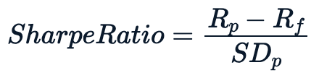

**where:**

R_p- Return of portfolio

R_f - Risk free rate

SD_p - stardard deviation of the portfolio's excess returns.

we are going to presume that the current risk free rate is 0% The reasoning behind setting the risk-free rate to zero is not only for simplicity, but because any action is inherently risky in some fashion, especially when you consider receiving a reward. Therefore, some may argue that the true risk-free rate is actually 0, while others may argue that there are risk-free assets that it should be based on.

Usually, any Sharpe ratio greater than 1.0 is considered acceptable to good by investors. A ratio higher than 2.0 is rated as very good. A ratio of 3.0 or higher is considered excellent. A ratio under 1.0 is considered sub-optimal. As a rule of thumb, a Sharpe ratio above 0.5 is market-beating performance if achieved over the long run. A ratio of 1 is superb and difficult to achieve over long periods of time. A ratio of 0.2-0.3 is in line with the broader market.

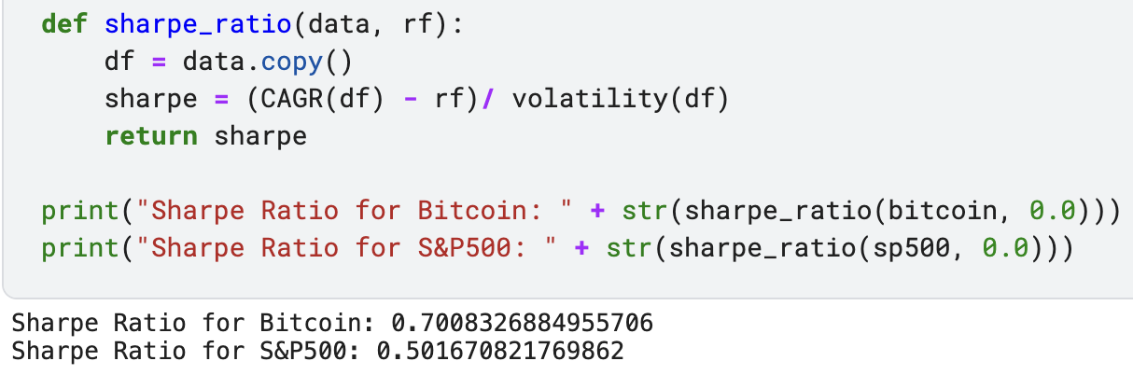

**7.4 Sortino Ratio**

Sortino Ratio is similar to the Sharpe Ratio except that it only considers the standard deviation of the negative portfolio returns instead of the total overall volatility. The usage of the Sortino Ratio is based on the presumption that the negative deviation of a portfolio’s returns from the mean will give a better view of a portfolio’s performance. The Sortino ratio measures the risk-adjusted return of an investment asset, portfolio, or strategy. It is a modification of the Sharpe ratio but penalizes only those returns falling below a user-specified target or required rate of return, while the Sharpe ratio penalizes both upside and downside volatility equally. The Sortino Ratio helps an investor determine an investment's return relative to risk. It may also differentiate between investments with varied returns and risk profiles. As a result, it essentially helps level the playing field when it comes to risk. The formula of Sortino Ratio is as follows:

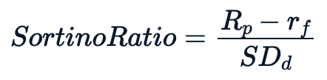

**where:**

R_p- Return of portfolio

r_f - Risk free rate

SD_d - stardard deviation of the negative volatility.

As a rule of thumb, a Sortino ratio of 2 and above is considered ideal. Thus, An investmenf below 0.5 is unacceptable

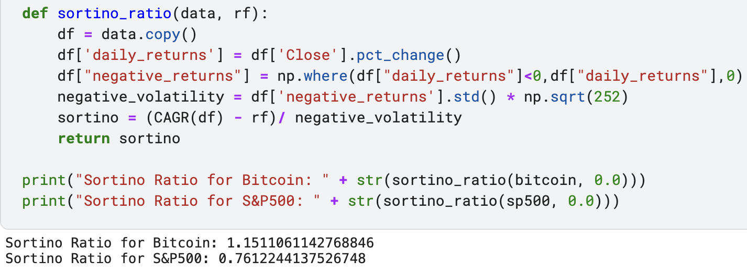

**8. Consumer price index and Inflation**

A consumer price index measured changes in the price level of market basket of consumer goods and services purchase by households. CPI is measuring the cost if living through time. Basically, the value of a dollar or what we can buy with the dollar how it changes through time. When CPI increase it means the value of the amount save in the beginning has reduces. So if you invested in some certain stock that has hedge against inflation at the beginning year you would have beaten inflation but a saved money would have lost its purchasing power.

As we can see the graph of the CPI( consumer price index)/Inflation rate increase by almost 25% form september 2016 till date considering the inflation during 7 years. This is quite dangerous to some economy.

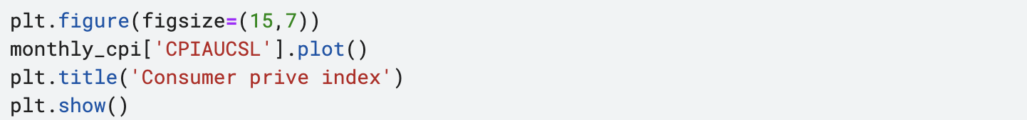

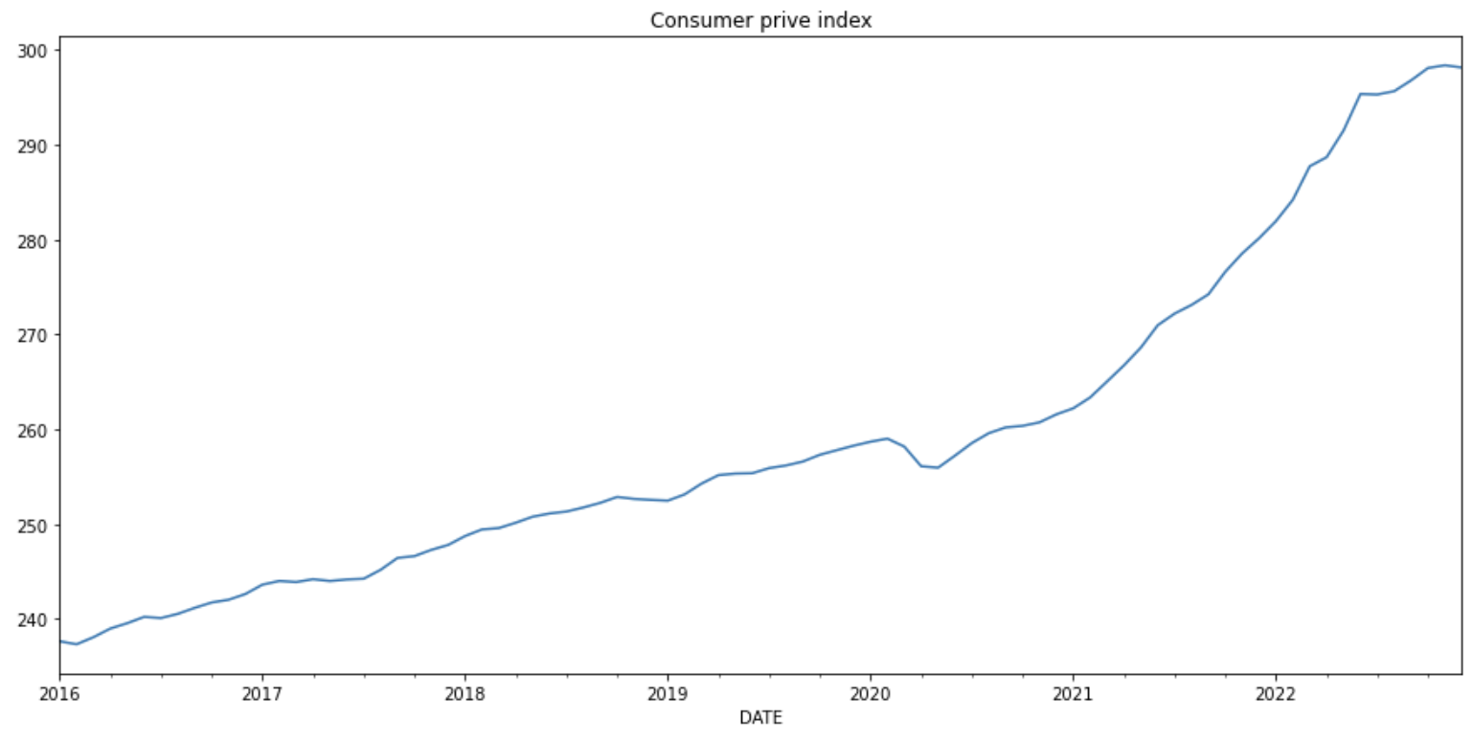

The graph below is the cpi percentage change. As we see there is a lower spike in early 2020, if we look at the CPI we ploted earlier there was a fall around this times.

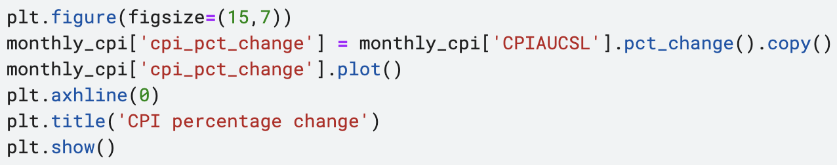

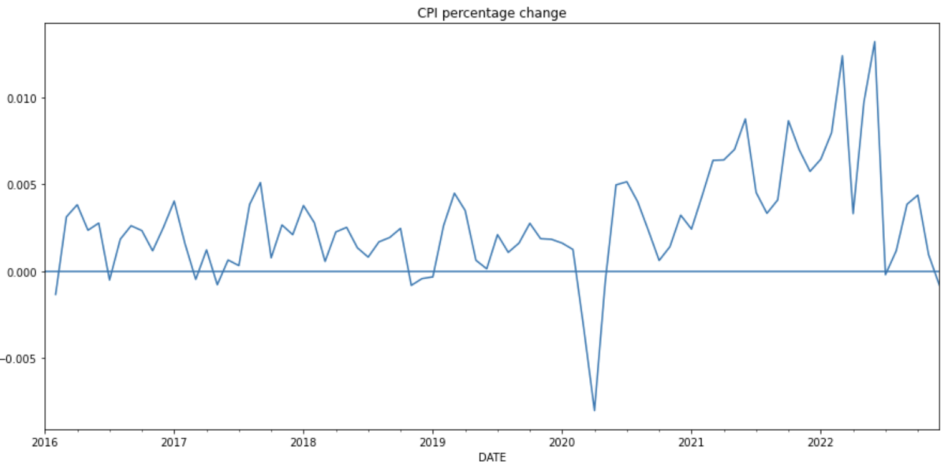

**8.1 Adjustment of stock against inflation**

We want to be able to Adjust bitcoin and sp500 if it would be able to hedge inflation. we created the together data to be able so to this analysis.

We can see that the two plots are very different. For the bitcoin vs inflation graph, from the beginning inflation had not affected the stock from 2016. We can say that bitcoin has a hedge against inflation than that of S&P500. To further explain this investing in bitcoin is more promising than that of S&P500 because the purchasing power of the investment of Bitcoin did not quite drop, having 1 dollar of bitcoin over the years is 60,000 dollars supposed to have the purchasing power of worth 60,000 dollars but has the purchasing power of 52,000 dollars.

Look at the S&P500 vs inflation graph in 2016 having 2000 dollars of S&P500 stock over the years is supposed to worth 4850 dollars but has the purchasing power of less than 4000 dollars.

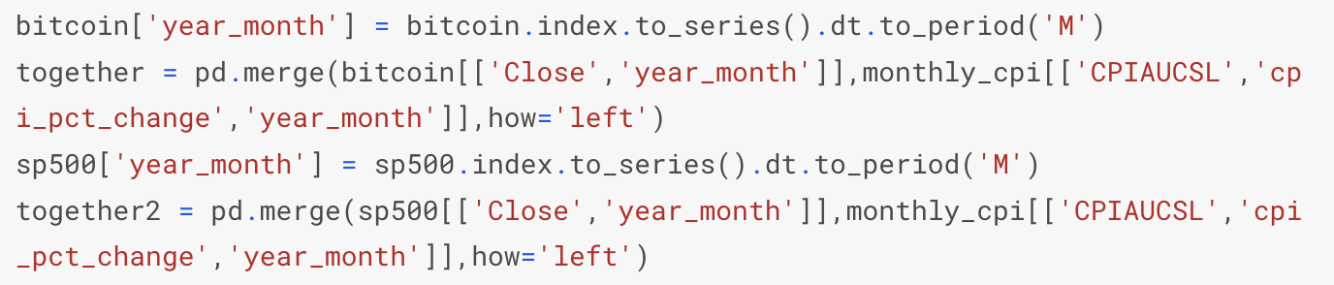

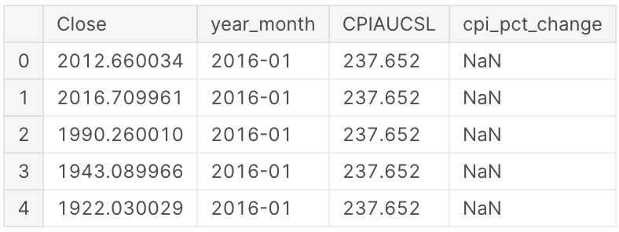

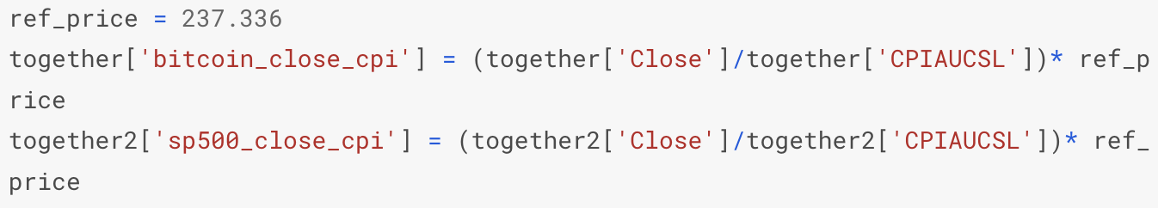

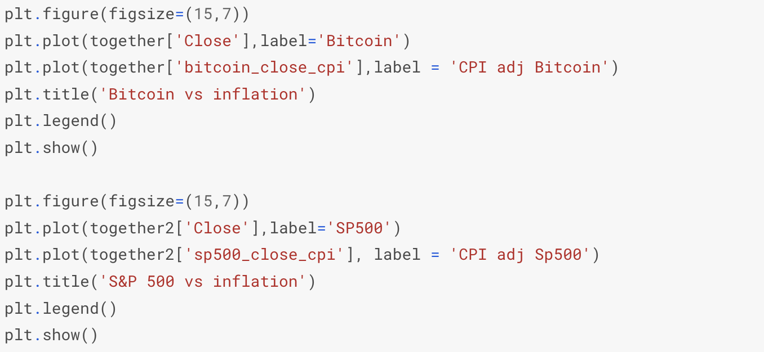

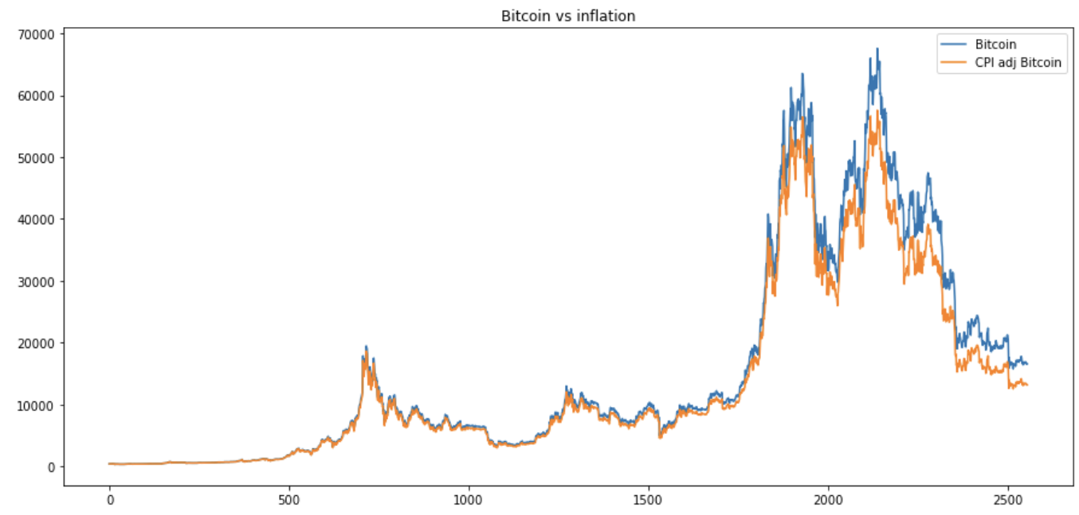

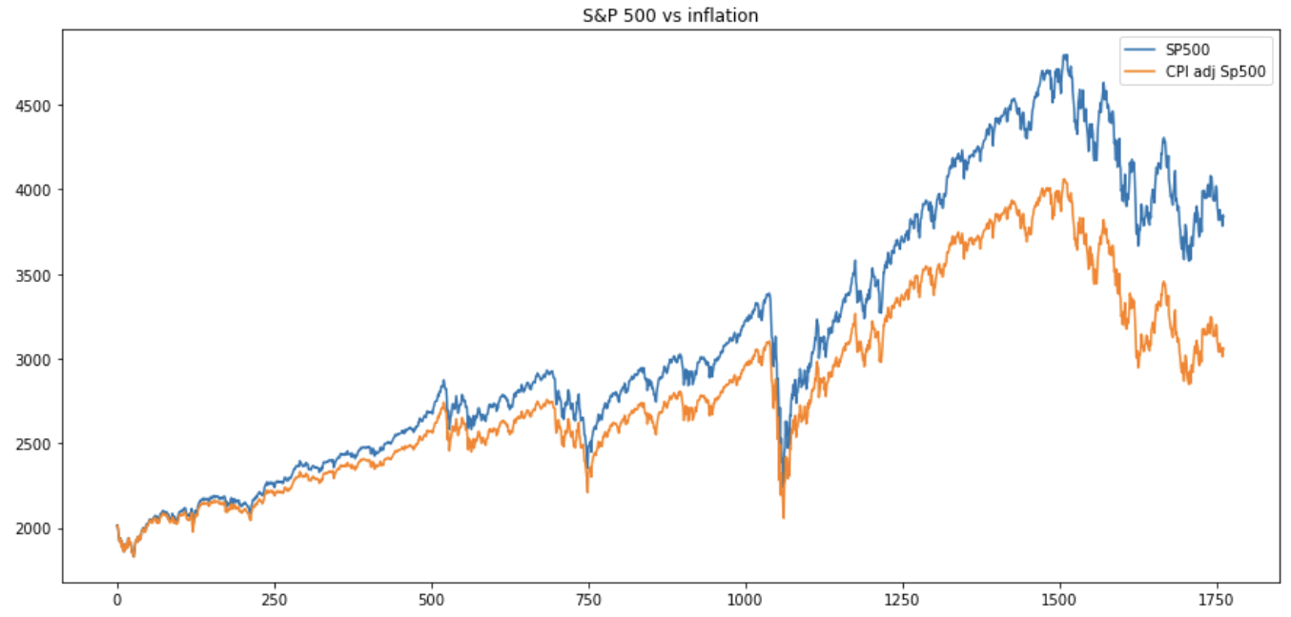

# **Observations**

* We found out that from 2016 January to 2022 December Bitcoin has really grown more than S&P500.
* we viewed the diagrams and graph that show the amount of volatility of the two stock prices. we use the histograms, kde and boxplot to see the volatility. we found out that Bitcoin is more volatile than that of S&P 500.
* We did calculations to develop the investment portfolio performance, we use the CAGR, Annuallized Volatility, Sharpe ratio and Sortino ratio.
* We saw a visualization of bitcoin vs the inflation over the years. We can say that in the long run inflation affects bitcoin investment. As for S&P500, inflation has affected the stock so an investment in the stock would lose its purchasing power.

# **Recommendations**

One potentially less volatile strategy is investors could consider is value stock investing which is when an investor choose stock that may be underpriced. Some investors turn to gold and all the precious metals, which have been considered a hedge against inflation for a long time. Basically, because they are real tangible assets.

Bitcoin, on the other hand has shown traits that is less susceptible to the effects of inflation because it has a certain number of coins that can be circulated. The Sharpe ratio of bitcoin is sub-optimal so an investment isn’t really a good choice and also the Sortino ratio is below 2 which is not a perfect investment. The risk involve in Bitcoin is quite high. I Recommend that as a Bitcoin investor to minimize the risk you should consider investing in the long run and using platforms that has Stop loss orders. A stop-loss order is an order placed with a broker to buy or sell a specific stock once the stock reaches a certain price. A stop-loss is designed to limit an investor's loss on a security position. For example, setting a stop-loss order for 10% below the price at which you bought the stock will limit your loss to 10%. At this rate Bitcoin risk is reduce and in the long run. Bitcoin has shown trait to increases in value.

# **Conclusion**

This financial analysis has shown that inflation can also be a pain when it comes to investing in stocks. Over the years bitcoin had a very high cumulative return but after 2022 its price fall down very quickly too. we got to see calculations for stock markets and explain vigorously. we recommended stop loss and long-term investment for bitcoin. Bitcoin is still very new and very volatile which makes it hard to draw conclusions.

Bitcoin is a very speculative investment. It involves a lot of risk and may not be suitable for everyone.